

This API converts parameters into CSV format for CDR (Call Detail Record) data.

**Endpoint list:**

#/createCdr

Http method:Post

**Default Request Parameter:**

CallerIDNumber (optional)

CalledNumber (optional)

SIPCallID (optional)

RemoteIPAddress (optional)

Direction (optional)

CallStartDatetime (optional)

CallAnswerDatetime (optional)

CallEndDatetime (optional)

Duration (optional)

BillSecond (optional)

ProgressSecond (optional)

AnswerSecond (optional)

WaitSecond (optional)

HangupCause (optional)

HangupCauseQ850 (optional)

SipHangupDisposition (optional)

UUID (optional)

BLegUUID (optional)

**Example request body in JSON format:**

{

"CallerIDNumber": "123456789",

"CalledNumber": "987654321",

"SIPCallID": "abc123def456",

"RemoteIPAddress": "192.168.0.1",

"Direction": "Outgoing",

"CallStartDatetime": "2022-01-01T09:00:00Z",

"CallAnswerDatetime": "2022-01-01T09:01:00Z",

"CallEndDatetime": "2022-01-01T09:05:00Z",

"Duration": 300,

"BillSecond": 280,

"ProgressSecond": 30,

"AnswerSecond": 15,

"WaitSecond": 5,

"HangupCause": "Normal Clearing",

"HangupCauseQ850": "16",

"SipHangupDisposition": "completed",

"UUID": "a1b2c3d4e5f6",

"BLegUUID": "f6e5d4c3b2a1"

}

**Example curl in window command prompt:**

curl -X POST -H "Content-Type: application/json" -d "{\"CallerIDNumber\":\"123456\",\"CalledNumber\":\"987654\",\"SIPCallID\":\"abc123\",\"RemoteIPAddress\":\"192.168.0.1\",\"Direction\":\"Outgoing\",\"CallStartDatetime\":\"2022-01-01 09:00:00\",\"CallAnswerDatetime\":\"2022-01-01 09:01:00\",\"CallEndDatetime\":\"2022-01-01 09:05:00\",\"Duration\":300,\"BillSecond\":280,\"ProgressSecond\":30,\"AnswerSecond\":15,\"WaitSecond\":5,\"HangupCause\":\"Normal Clearing\",\"HangupCauseQ850\":\"16\",\"SipHangupDisposition\":\"completed\",\"UUID\":\"xyz789\",\"BLegUUID\":\"456def\"}" <http://localhost:3000/createCdr>

**Response:**

errorCode and errorMessage

**Success result:**

{ errorCode: "000", errorMessage: "success" }

**Fail result:**

{ errorCode: "001", errorMessage: fail reason }

**Csv file after added new record:**



**Configuration path:**

./conf/app.conf

Default port is 3000

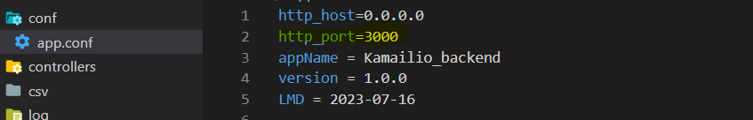

#The http_port can be modified or customized by editing the configuration file.

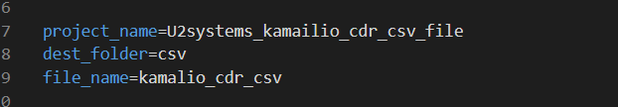

#The project_name refers to the name of the project.

#The dest_folder configuration specifies the directory where the CDR CSV files are stored.

#The file_name represents the header filename for the CDR CSV file.

**The request parameters can be configured/customized based on specific needs or requirements in app.conf file:**

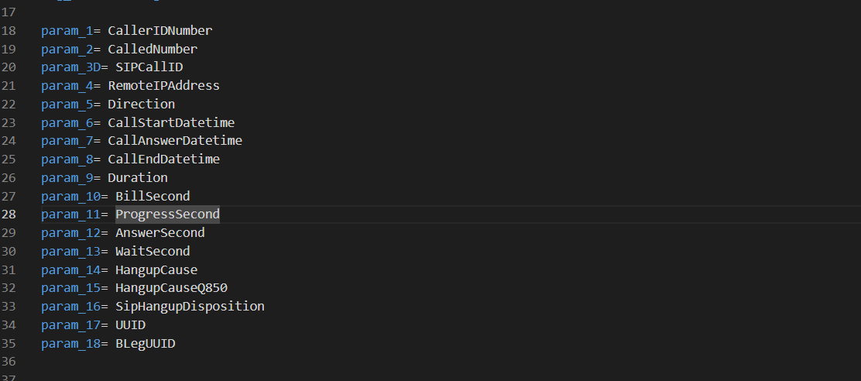

To add a new parameter, follow the format param_{anything_unique}={parameter_name} in the configuration file

**Example new parameter declaration:**

param_19= callTimeDuration

param_totalduration= totalDuration

**Default cdr.csv file located at csv folder:**

